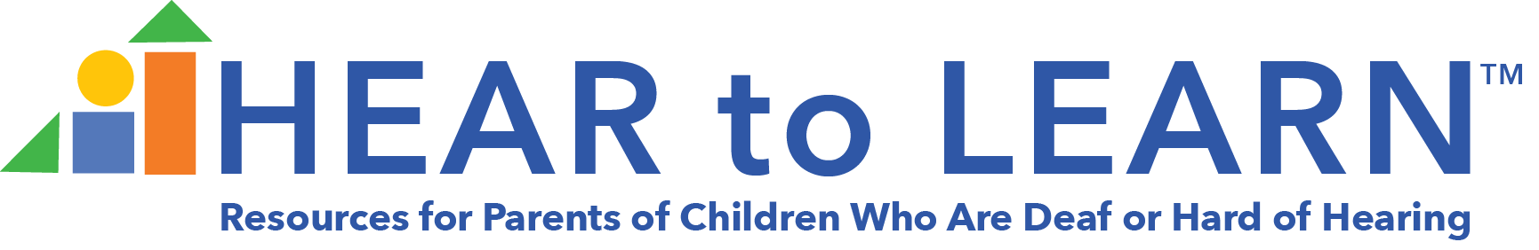

Links for Session Handouts

Date of Webinar: 10/1/2021
Topic: Promoting Language and Literacy Through Daily Routines and Activities
Presenter: Lauri Nelson, PhD

https://www.hearingfirst.org/b/blog/posts/growing-listening-language-and-literacy-skills-tips-for-lsl-interventionists-ebook

https://www.jtc.org/family-activities/

https://hearandnow.cochlearamericas.com/hearing-solutions/services/experience-books-for-cochlear-implant/

https://www.nichd.nih.gov/sites/default/files/publications/pubs/documents/PRFbrochure.pdf

https://www.hearingfirst.org/search?q=books%20with%20repeatable%20lines

https://www.hearingfirst.org/search?q=read%20aloud%20stages

